Chhatrapati Shivaji Maharaj Chhatrapati Shivaji Maharaj

Chhatrapati Shivaji Maharaj Chhatrapati Shivaji Maharaj

Chhatrapati Shivaji Maharaj

Chhatrapati Shivaji Maharaj

Chhatrapati Shivaji Maharaj

Chhatrapati Shivaji Maharaj

Chhatrapati Shivaji Maharaj

Chhatrapati Shivaji Maharaj

Chhatrapati Shivaji Maharaj

Chhatrapati Shivaji Maharaj

Chhatrapati Shivaji Maharaj

Chhatrapati Shivaji Maharaj

Chhatrapati Shivaji Maharaj

|  |
| --- |
| **SHIVAJI MAHARAJA** |

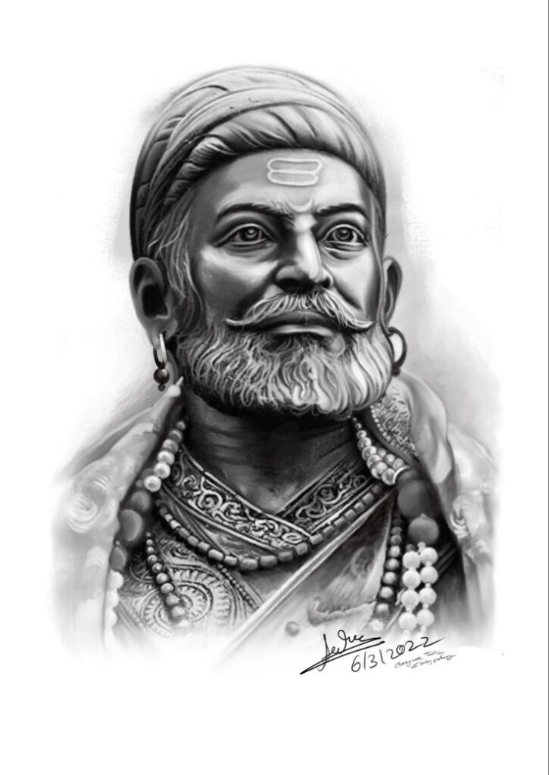

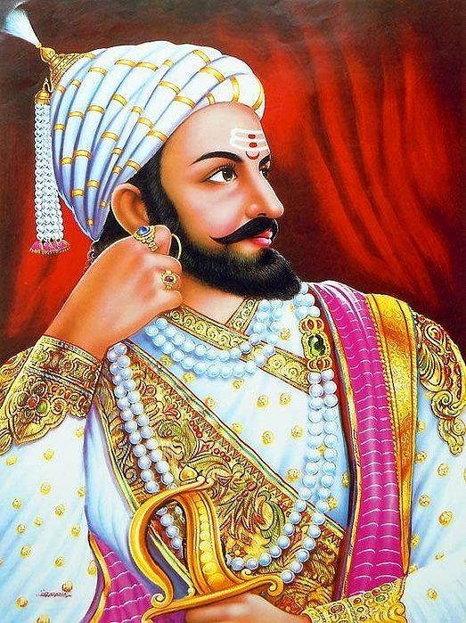

**SHIVAJI MAHARAJ** was a 17th-century Indian warrior and founder of the Maratha Empire, known for his military prowess, innovative guerrilla warfare tactics, and progressive administrative policies that challenged the [Mughal Empire](https://www.google.com/search?sca_esv=53f892ddff1617d9&q=Mughal+Empire&sa=X&sqi=2&ved=2ahUKEwiQh-3z4NyPAxXxXmwGHSCxBX8QxccNegQIKhAC&mstk=AUtExfC8XKHxQ49aHzoPaAHAdJG0YSTcWLDBY7jCRC0xiJeeRYOn9zQQqGZzLyR14KOKsNa-SCuuI5Oq2uZMgtgFAeCbSA-X9gH0LVjW4ELLdRSRW_eowsh020XmWMozktHi43g&csui=3). Born in 1630, he captured his first fort, Torna, at age 16, leading to his coronation as [Chhatrapati](https://www.google.com/search?sca_esv=53f892ddff1617d9&q=Chhatrapati&sa=X&sqi=2&ved=2ahUKEwiQh-3z4NyPAxXxXmwGHSCxBX8QxccNegQIKxAB&mstk=AUtExfC8XKHxQ49aHzoPaAHAdJG0YSTcWLDBY7jCRC0xiJeeRYOn9zQQqGZzLyR14KOKsNa-SCuuI5Oq2uZMgtgFAeCbSA-X9gH0LVjW4ELLdRSRW_eowsh020XmWMozktHi43g&csui=3) (sovereign) in 1674 and the formal establishment of an independent Maratha kingdom. Shivaji Maharaj is celebrated for creating a unified Hindu kingdom, fostering self-reliance, and uniting people under his vision of Hindavi Swarajya (self-rule).

**EARLY LIFE AND RISE TO POWER**

Shivaji was born in 1630 to Shahaji Bhosale and Jijabai at [Shivneri Fort](https://www.google.com/search?sca_esv=53f892ddff1617d9&q=Shivneri+Fort&sa=X&sqi=2&ved=2ahUKEwiQh-3z4NyPAxXxXmwGHSCxBX8QxccNegQINBAB&mstk=AUtExfC8XKHxQ49aHzoPaAHAdJG0YSTcWLDBY7jCRC0xiJeeRYOn9zQQqGZzLyR14KOKsNa-SCuuI5Oq2uZMgtgFAeCbSA-X9gH0LVjW4ELLdRSRW_eowsh020XmWMozktHi43g&csui=3" \t "_blank) in Maharashtra. His mother instilled in him a strong sense of justice and responsibility.

* **Formation of a Movement:**

**By age 16, Shivaji gathered a loyal band of followers, known as Maavalas, to fight for** a Maratha kingdom, and in 1645, he captured the [Torna Fort](https://www.google.com/search?sca_esv=53f892ddff1617d9&q=Torna+Fort&sa=X&sqi=2&ved=2ahUKEwiQh-3z4NyPAxXxXmwGHSCxBX8QxccNegQIQBAB&mstk=AUtExfC8XKHxQ49aHzoPaAHAdJG0YSTcWLDBY7jCRC0xiJeeRYOn9zQQqGZzLyR14KOKsNa-SCuuI5Oq2uZMgtgFAeCbSA-X9gH0LVjW4ELLdRSRW_eowsh020XmWMozktHi43g&csui=3), marking the beginning of his expansionist campaign.

* **CONFRONTATIONS:**

He strategically acquired forts and territories from the [Bijapur Sultanate](https://www.google.com/search?sca_esv=53f892ddff1617d9&q=Bijapur+Sultanate&sa=X&sqi=2&ved=2ahUKEwiQh-3z4NyPAxXxXmwGHSCxBX8QxccNegUInQEQAQ&mstk=AUtExfC8XKHxQ49aHzoPaAHAdJG0YSTcWLDBY7jCRC0xiJeeRYOn9zQQqGZzLyR14KOKsNa-SCuuI5Oq2uZMgtgFAeCbSA-X9gH0LVjW4ELLdRSRW_eowsh020XmWMozktHi43g&csui=3) and engaged in guerrilla warfare against the [Mughal Empire](https://www.google.com/search?sca_esv=53f892ddff1617d9&q=Mughal+Empire&sa=X&sqi=2&ved=2ahUKEwiQh-3z4NyPAxXxXmwGHSCxBX8QxccNegUInQEQAg&mstk=AUtExfC8XKHxQ49aHzoPaAHAdJG0YSTcWLDBY7jCRC0xiJeeRYOn9zQQqGZzLyR14KOKsNa-SCuuI5Oq2uZMgtgFAeCbSA-X9gH0LVjW4ELLdRSRW_eowsh020XmWMozktHi43g&csui=3), eventually defeating notable Mughal generals like [Shaista Khan](https://www.google.com/search?sca_esv=53f892ddff1617d9&q=Shaista+Khan&sa=X&sqi=2&ved=2ahUKEwiQh-3z4NyPAxXxXmwGHSCxBX8QxccNegUInQEQAw&mstk=AUtExfC8XKHxQ49aHzoPaAHAdJG0YSTcWLDBY7jCRC0xiJeeRYOn9zQQqGZzLyR14KOKsNa-SCuuI5Oq2uZMgtgFAeCbSA-X9gH0LVjW4ELLdRSRW_eowsh020XmWMozktHi43g&csui=3) and Bijapur's [Afzal Khan](https://www.google.com/search?sca_esv=53f892ddff1617d9&q=Afzal+Khan&sa=X&sqi=2&ved=2ahUKEwiQh-3z4NyPAxXxXmwGHSCxBX8QxccNegUInQEQBA&mstk=AUtExfC8XKHxQ49aHzoPaAHAdJG0YSTcWLDBY7jCRC0xiJeeRYOn9zQQqGZzLyR14KOKsNa-SCuuI5Oq2uZMgtgFAeCbSA-X9gH0LVjW4ELLdRSRW_eowsh020XmWMozktHi43g&csui=3).

Establishing the Maratha Empire

* **ADMINISTRATIVE REFORMS:**

He established a progressive civil administration based on a council of eight ministers, known as the [Astapradhan](https://www.google.com/search?sca_esv=53f892ddff1617d9&q=Astapradhan&sa=X&sqi=2&ved=2ahUKEwiQh-3z4NyPAxXxXmwGHSCxBX8QxccNegUIvQIQAQ&mstk=AUtExfC8XKHxQ49aHzoPaAHAdJG0YSTcWLDBY7jCRC0xiJeeRYOn9zQQqGZzLyR14KOKsNa-SCuuI5Oq2uZMgtgFAeCbSA-X9gH0LVjW4ELLdRSRW_eowsh020XmWMozktHi43g&csui=3" \t "_blank). He also created a competent navy to protect the coastline.

* **CULTURAL AND LINGUISTIC REVIVAL:**

Shivaji promoted the use of Marathi and Sanskrit languages, replacing Persian in his court and administration, and resurrected ancient Hindu political traditions.

Legacy and Impact

* **INSPIRATION FOR SELF-RULE:**

His leadership united the people and instilled pride in the concept of independent rule (Hindavi Swarajya), inspiring future generations to fight for self-reliance.

* **RELIGIOUS TOLERANCE:**

Despite his devout Hindu beliefs, Shivaji was known for his respect for other faiths, welcoming Muslims into his service and safeguarding their religious sites.

* **MILITARY STRATEGY:**

His innovative use of guerrilla warfare, combined with a strong naval force and a network of strategically built and captured forts, laid the foundation for the Maratha Empire's future expansion.

* Shivaji | Biography, Reign, & Facts - Britannica

Collecting a band of followers, he began about 1655 to seize the weaker Bijapur outposts. In the process, he destroyed a few of hi...

Britannica

* About Chhatrapati Shivajhi Maharaj - Shivaji College - University of Delhi

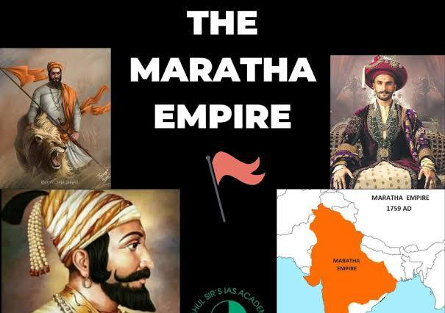

**👑**

|  |
| --- |
| **Shivaji Maharaj Family Tree** |
|  |
| |  |  |  |  | | --- | --- | --- | --- | |  |  |  |  | | Ancestor | Maloji Bhosale | Grandfather | Military commander under Ahmadnagar Sultanate | | Parent | Shahaji Bhosale | Father | Maratha general under Bijapur Sultanate | | Parent | Jijabai | Mother | Spiritual guide and mentor to Shivaji | | Shivaji Maharaj | Chhatrapati Shivaji | — | Founder of Maratha Empire | | Wife | Saibai | First wife | Mother of Sambhaji | | Wife | Soyarabai | Second wife | Mother of Rajaram | | Other Wives | Putalabai, Sagunabai, Kashibai, Lakshmibai, Gunwantabai | — | Mostly ceremonial or political alliances | | Son | Sambhaji Maharaj | Eldest son | 2nd Chhatrapati; executed by Mughals in 1689 | | Son | Rajaram Maharaj | Younger son | 3rd Chhatrapati; led resistance from Gingee Fort | | Grandson | Shahu Maharaj | Son of Sambhaji | 5th Chhatrapati; expanded Maratha power | | Grandson | Shivaji II | Son of Rajaram & Tarabai | Claimed throne; faced succession disputes | |

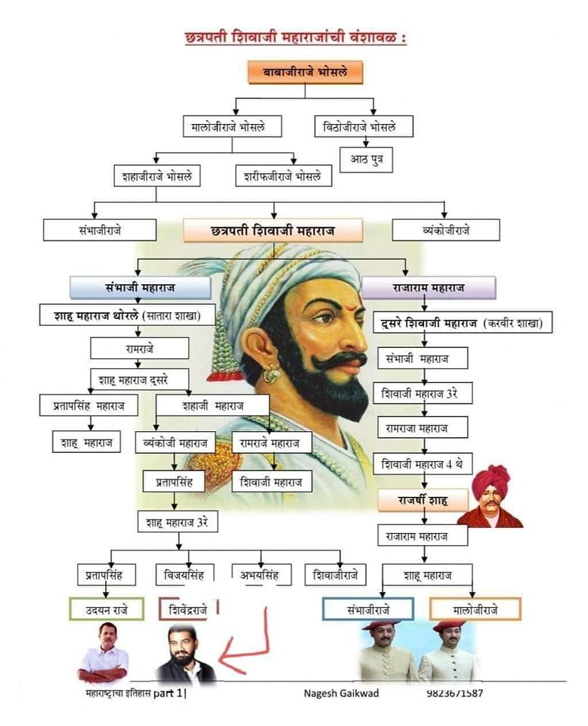

* Show all